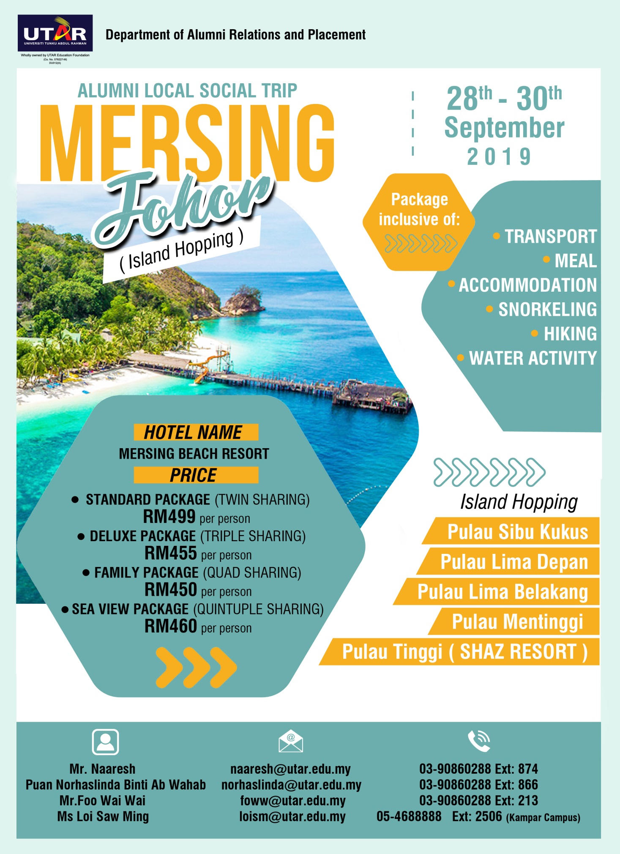
28 September 2019 (SATURDAY)

Day 1:
7.00am – Depart from Sg. Long Campus
12.00pm – Arrive at Kluang
3.00pm – Check in Hotel Mersing
~ Easy & Free

6.30pm – BBQ Dinner
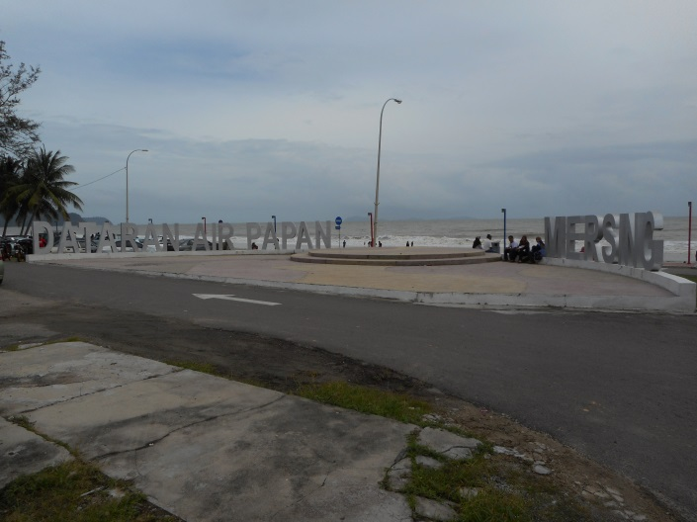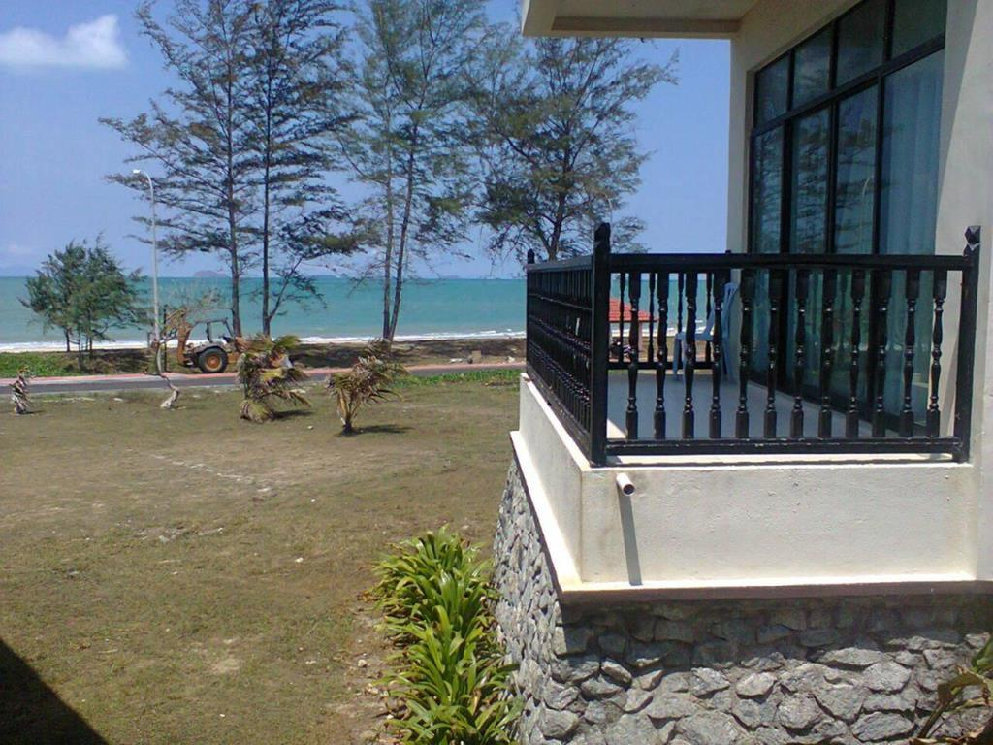
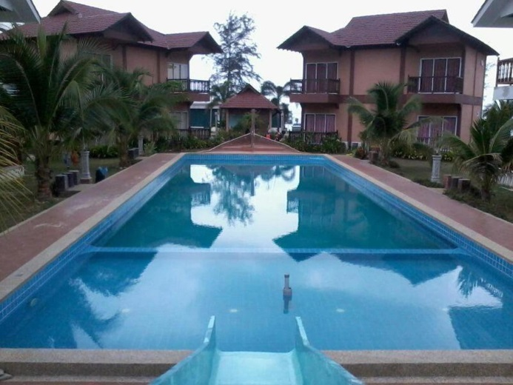
29 September 2019 (SUNDAY)

Day 2:
7.00am-8.00am – Breakfast
8.30am – Jeti ~ Briefing
10.00am – Hiking at Sibu Kukus Island
11.30am – Snorkeling & lunch at Lima Island
2.00pm – Snorkeling Mentinggi Island
3.30pm - Hi Tea at Shaz Resort Tinggi
6.00pm - Jeti
7.00pm-9.00pm – Dinner at hotel

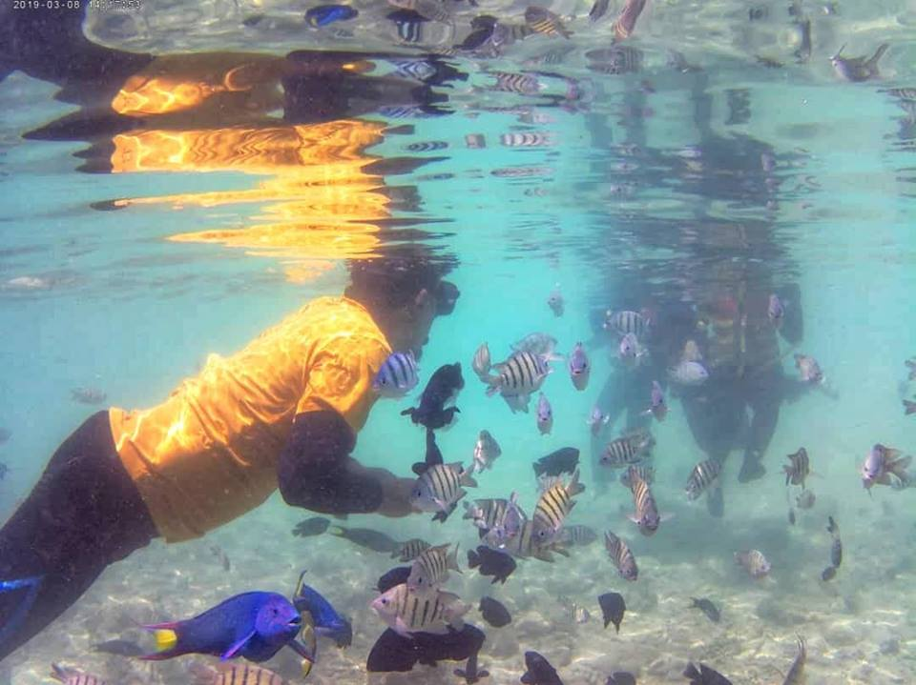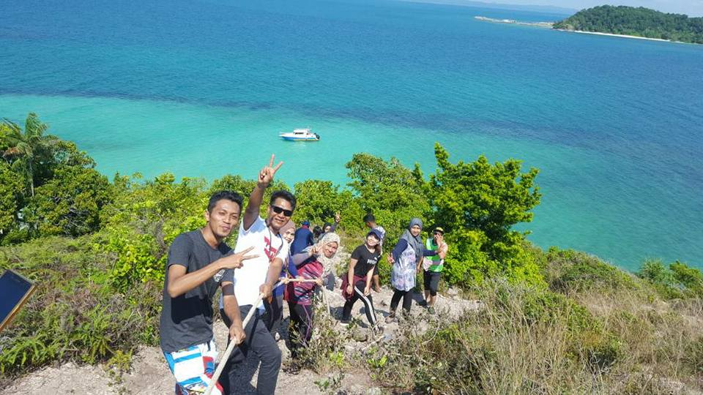
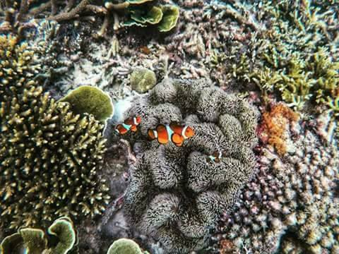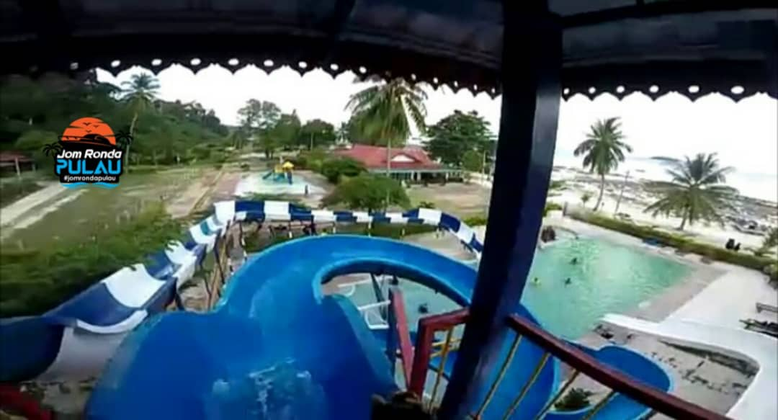
30 September 2019 (MONDAY)

Day 3:
7.30am-9.30am – Breakfast
11.00am – Check Out
1.30pm – Arrive at Ayer Hitam
4.00pm - Depart to Sg. Long Campus
8.00pm - Arrive at Sg. Long Campus
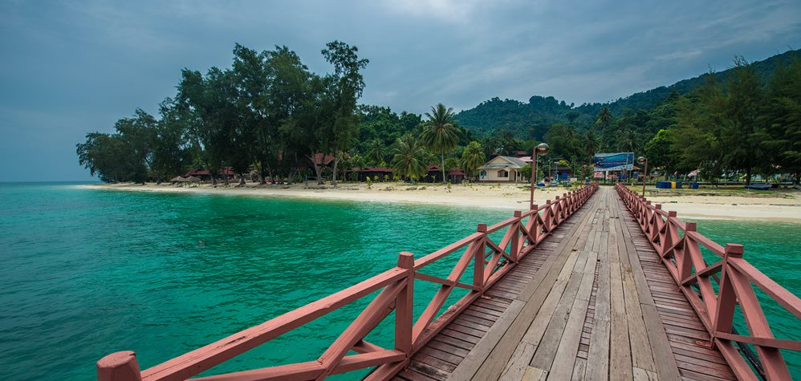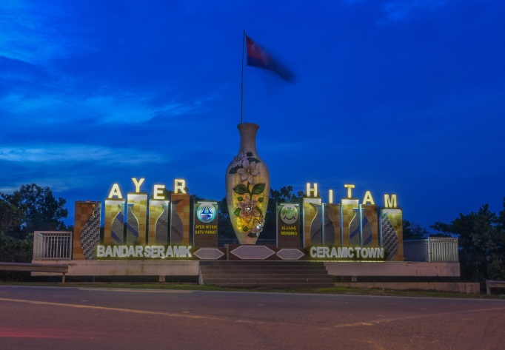

*Organiser reserved the right to change the above itinerary based on local arrangement.
Department of Alumni Relations and Placement (DARP) Contact Persons:

- Foo Wai Wai: 0169392331
- Norhaslinda : 017-3532325
- Naaresh: 011-2649 5383

Thank you for your support and we do look forward to see you in coming DARP events!

